NATIONAL UNIVERSITY OF SCIENCE AND TECHNOLOGY

SCHOOL OF MECHANICAL AND MANUFACTURING ENGINEERING

SMME

FUNDAMENTALS OF PROGRAMMING

LAB MANUAL 4

LAB TASK

MUHAMMAD USMAN ABDULLAH

ME-15-B

461513

INSTRUCTOR: SIR AFFAN

COURSE INSTRUCTOR: KHAWAJA FAHAD IQBAL

19-OCT-2023

TASK 1:

#include <iostream>

using namespace std;

int main(){

int i,s,n;

s=0;

for(i=1;i<=10;i++){

cout<<"Enter a number"<<endl;

cin>>n;

s=s+n;

}

cout<<"The sum is"<<s<<endl;

return 0;

}

OUTPUT:

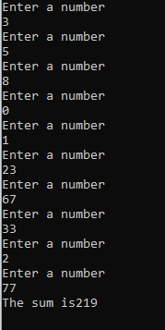

TASK 2:

#include <iostream>

using namespace std;

int main(){

int i, number;

cout<<"Enter the number for table"<<endl;

cin>>number;

for(i=1; i<11;i++)

{

cout<<number<<" \* "<<i<<" = "<<number\*i<<endl;

}

return 0;

}

OUTPUT:

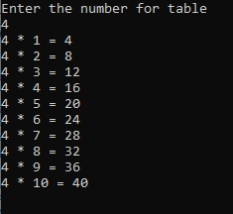

TASK 3:

#include <iostream>

using namespace std;

int main(){

int i,num, f;

f=1;

cout<<"Enter a number to find factorial"<<endl;

cin>>num;

for(i=1;i<=num;i++){

f=f\*i;

}

cout<<"The factorial of "<<num<<" is"<<f<<endl;

return 0;

}

OUTPUT:

